Issue #6  Jan/Feb | The Dogwood Dispatch  Department of Missouri Legislative  2023-2024 Promotional Material  Connection of sponsors Edition | Editor  Amy Jo Lett  10792 Mount Tabor Rd  Odessa, MO 64076  amyjo112910@yahoo.com  816-668-3164

Missouri Veterans Making Change MAVO Veterans' Rally 1/23/2024
The MAVO Veterans' Rally will be January 23, 2024, from 8:00 am to 10:00 am in the State of Missouri Capitol Rotunda located at 201 West Capitol Avenue, Jefferson City, Missouri 65101. After the Rally in the Rotunda, we will then break out into groups and visit our respective legislators to present MAVO's Legislative Agenda and ask for their support. If you have never been, our experienced members will help guide you in this vitally important event! We need all our Auxiliary Members and their Veterans to go talk to our Legislators and Gain their Support for MAVO’s Legislative Agenda.
- Stop Missouri Claim Sharks
- Eliminate Personal Property Taxes for Disabled Veterans
- Funding increase for VSO Grant Program
- Change Funding for MVC Employees to come from General Fund
___________________________________________________
Show Me Teamwork as We serve our Veterans by Banding together for our
Veterans, by uniting with the VFW to promote our 2023 Legislative Priority Goals
_______________________________________________
2024 VFW Legislative Conference March 3-7, 2024, in Washington, D.C.

Conference Information:

- 2024 Legislative Conference - Tentative Agenda
- Housing - Book Your Room
- VFW Events App Quick Start Guide
- VFW 2024 Priority Goals Brochure
- Sign Up for VFW Action Corps
Please, Consider going to this Legislative Conference. There is Power in Numbers!
💡 Legislative Project Ideas
Attend the 2024 VFW Legislative Conference and/or The MAVO Rally. Ask your Auxiliary to send someone to the Conference or the Rally. Make it a Group Event, everything's better with friends! Remember there is Power in Numbers! You could have a contest to see who can get the most people to attend the MAVO Veterans Rally! Get all of the information about our priority goals and what they are out into your community! Please don't forget to report projects! Go to www.vfwauxmo.org , Login and go to Members Only- Program Reporting and then Fill out the Report and Submit report! Please Report as soon as you complete the event.
Show your Community how to:

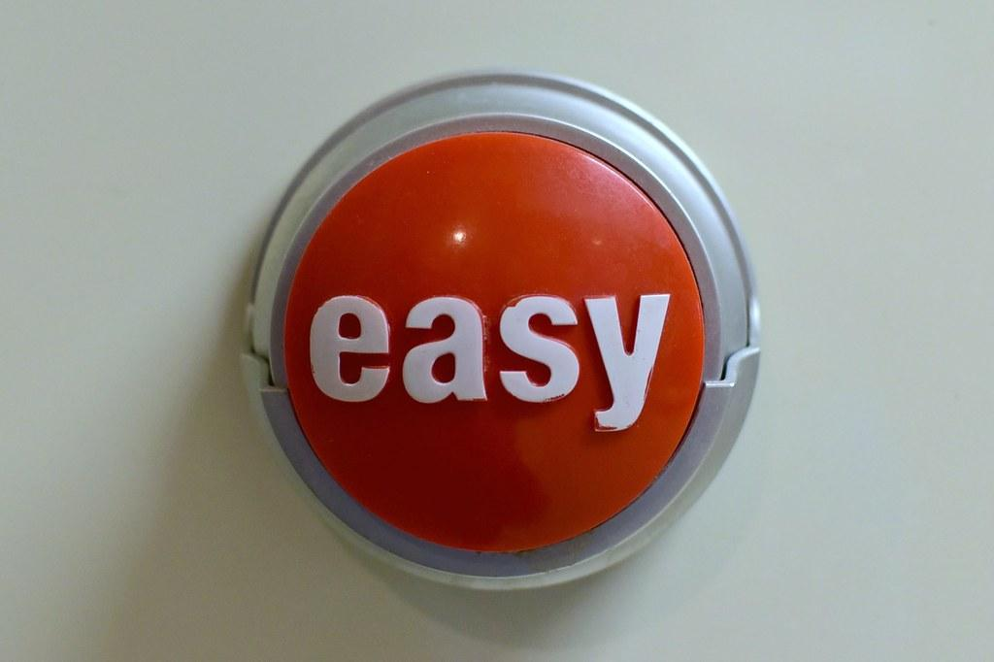
PUSH THE BUTTON
Currently in the Legislative Program we have
- 100 Projects
- 410 Members
- 179 Hours
- 521 Miles
- $610 Spent
We Thank You!!

